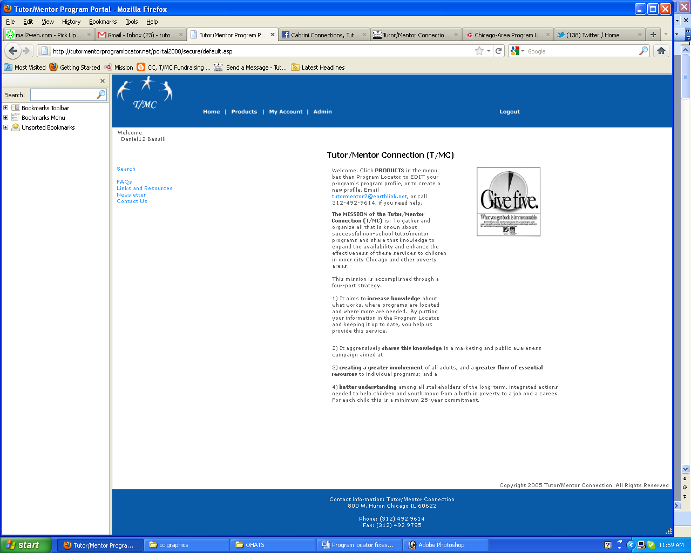

This name and address needs to change. I will change this again once I have a new address and phone. I don’t want to give my cell phone here.
Contact information:
Tutor/Mentor Connection -------
c/o Daniel Bassill, 833 Florence, Park Ridge, Il
email: tutormentor2@earthlink.net with questions
The text also needs to change. I’ll email you new text to put in here.
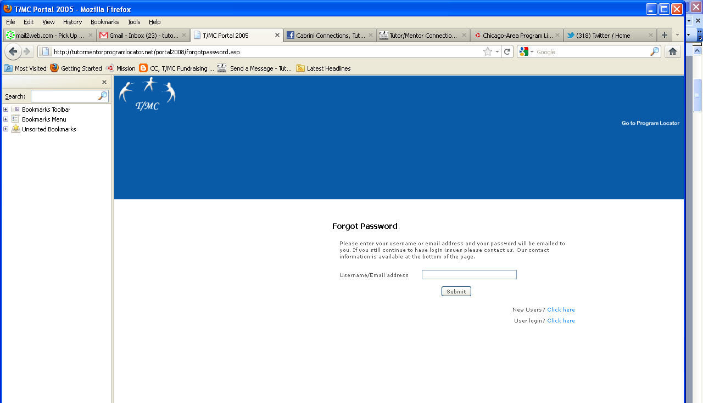

On this page when I submit my email address to get my password, I do not get the email sent to me.

On the “new user” feature, I’m not getting an email at tutormentor2@earthlink.net when a new user is added to the system
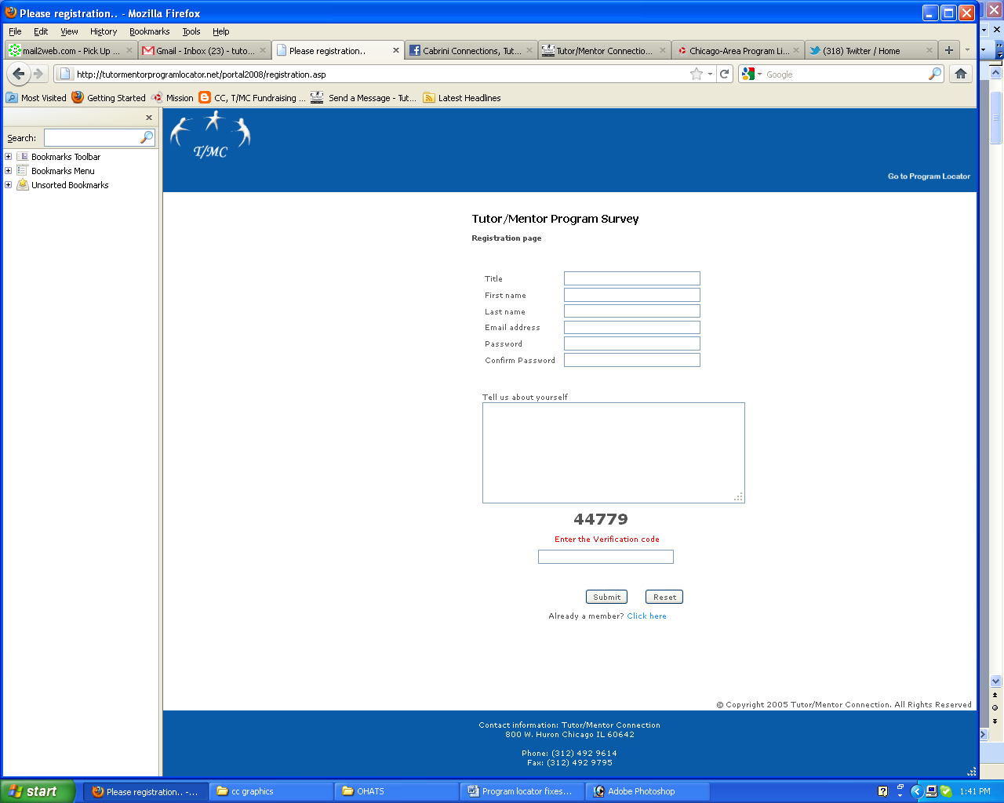

When a “new user” submits this form I’m not receiving an email notification. I don’t know when new people are trying to use the system.

.
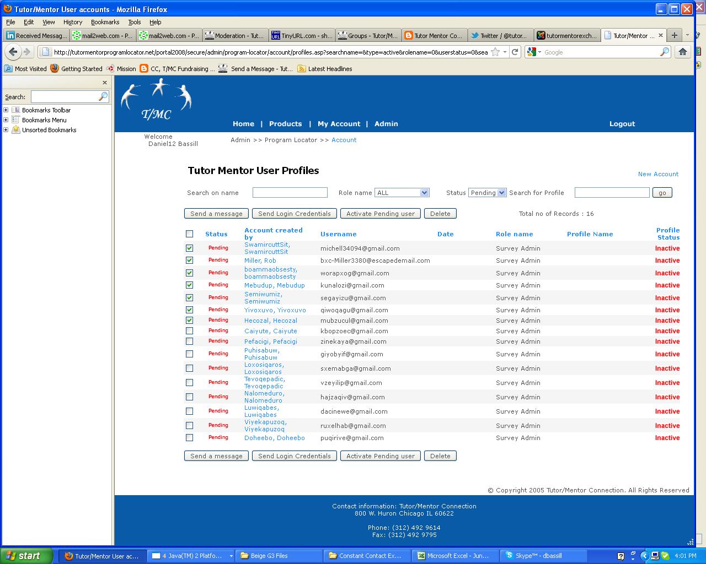

This is from User Profile page. I’ve sorted status to pending and it shows these people.
a) I’m not getting an email notice when someone sets up a profile
b) I can’t delete a group at one time
c) I can delete individual entries one at a time, but when I do it takes me back to the main User Profile page, then I need to sort for “pending” again in order to delete the next record. It needs to point back to the page I was working on after I make the deletion.
d) When I register as a “new user” my name shows on the “pending” list. When I activate that account and email should be sent to me telling me my account is active. That is not happening.
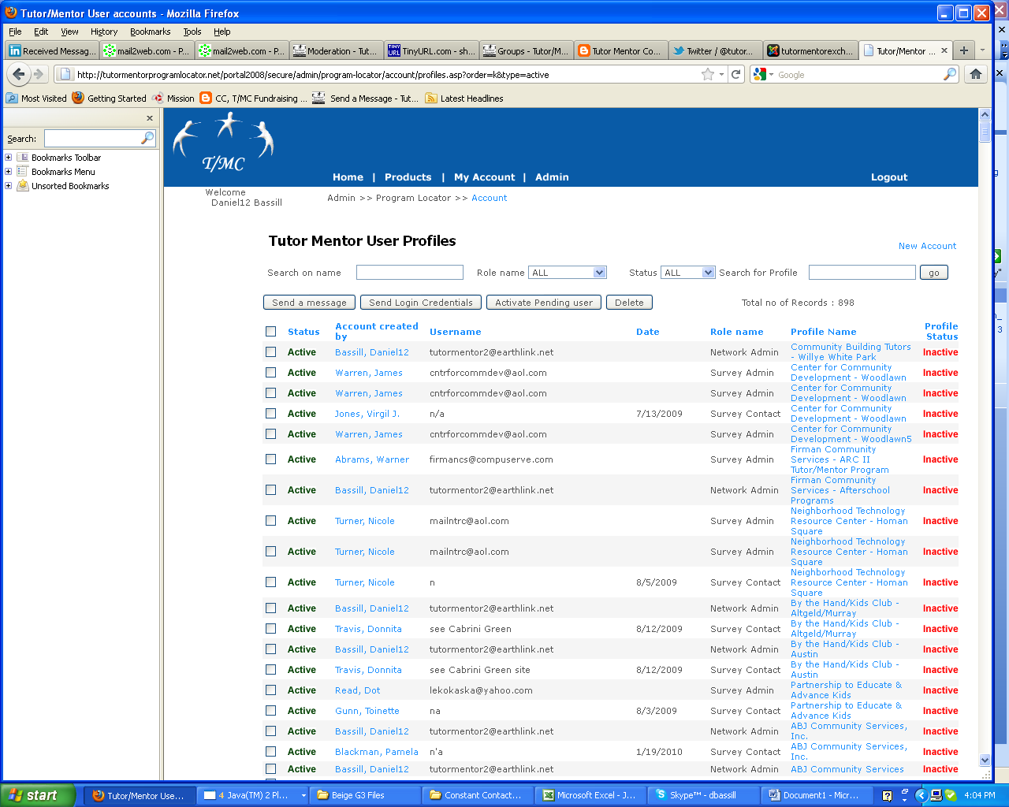
This shows the profile page, sorted by Profile Status (see far right).
We need to change the way this works so when we deactivate someone, they no longer show up on the screen. When someone is “pending” the profile status should say “pending” instead of “active” or “inactive”. That way we don’t delete people who just joined but are not yet active.

Send Message feature not working. I tried sending message to tutormentor2@earthlink.net
Send Login Credentials feature also not working

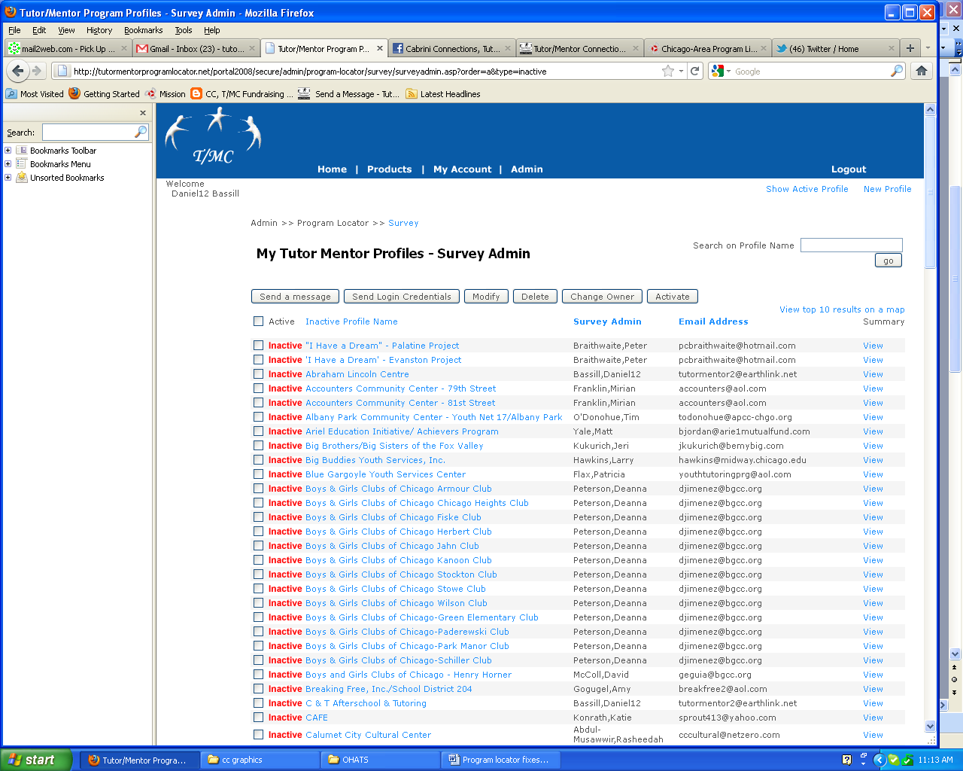
This page shows inactive surveys. It should have a designation of “pending” for those that have not been activated.

We need to change the way this works so a file that has been inactivated goes into an “archive” excel list, but no longer shows up in the survey admin tool. There should also be a “date” showing for last transaction so we know when these were de-activated.

See the next screen for another problem. I should see “Seed of Hope Foundation” on this list showing as an inactive profile.
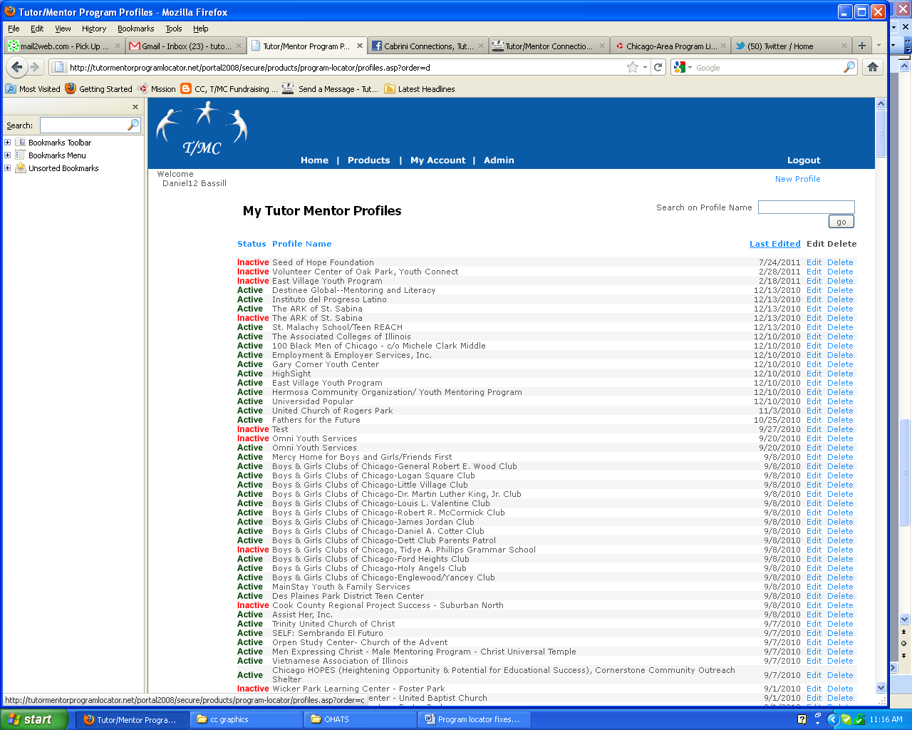

This is from the Program Profile List.
This shows Seed of Hope Foundation at the top, as an inactive profile. In the Survey Admin page I cannot find Seed of Hope Foundation. It should be showing up there so I can activate the account.

Instead of “inactive” it should show “pending” if it’s a new account. If I have deleted the account, or made it “inactive” it should no longer show up on the page but be archived in an excel sheet.

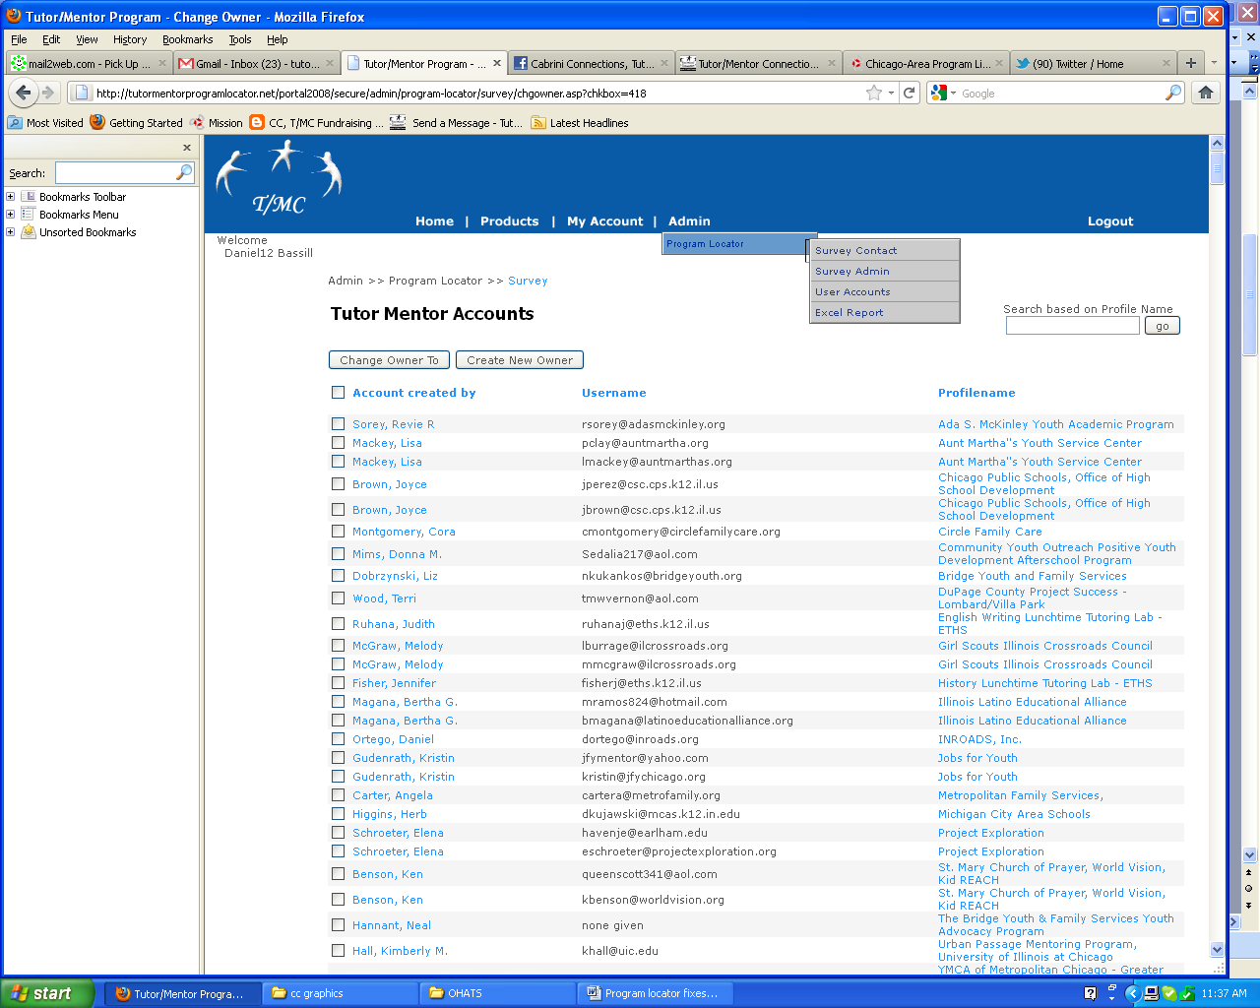

This page is only seen when you click “change owner” on the Survey Admin page. I think it should also show as one of the drop down menu listings.

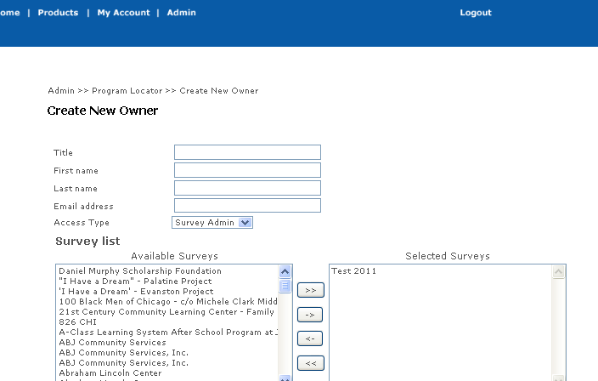
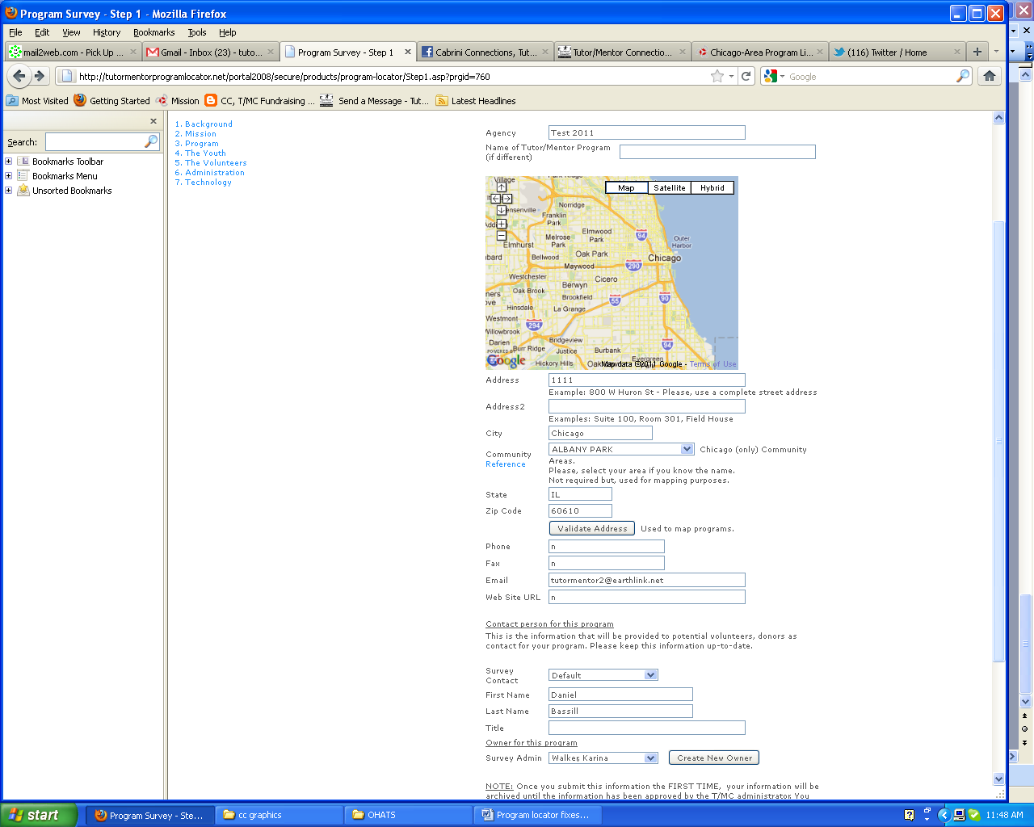

This is a TEST 2011 Survey in the Program Locator. I’ve changed the email to point to me and the survey contact to point to me.

I want to change the Survey Admin from Karina Walker to myself. However, when I try to create a new owner using an email already in the system, I cannot do that. Thus, if I want to change former staff to new staff I’m not able. This is a problem with how this works. The same email should be useable for multiple owners.

Or…an “administrator” email should be able to over ride the system so I can change multiple accounts to point to the same email address.

